COAL PROJECT REPORT
Project Title
Password Security System with Brute Force and Dictionary Attack Detection

Submitted By:
Sharf Ud Deen (243689)
Submitted To:
Mam Anum Aftab.

1.Introduction:
In modern computing systems, password-based authentication is one of the most commonly used security mechanisms. However, weak passwords and repeated login attempts make systems vulnerable to attacks such as brute force attacks and dictionary attacks. Ensuring password security is critical to protect sensitive information and system access.
This project implements a Password Security System using Assembly Language (EMU8086) that detects and prevents common password attacks. Although written in Assembly Language, the system heavily relies on such as arrays, counters, string comparison algorithms, conditional logic, and sequential searching. The system provides login functionality, attack detection, attempt tracking, and a detailed security audit report.

2.Problem Statement:
Many authentication systems fail to detect malicious login behavior such as repeated incorrect attempts or the use of common weak passwords. Attackers exploit these weaknesses to gain unauthorized access.
The problem addressed in this project is to design a lightweight and secure password authentication system that can:
- Detect brute force attacks based on repeated failed attempts.
- Detect dictionary attacks using a list of weak passwords.
- Lock the system after multiple failures.
- Maintain a security audit report.
- Be implemented efficiently using Data Structures & Algorithms concepts.

3. Objectives:

Primary Objectives:
- To design a secure password authentication system.
- To detect brute force attacks using attempt counters.
- To identify dictionary attacks using weak password matching.
- To lock the system after maximum failed attempts.
Secondary Objectives:
- To implement string comparison algorithms.
- To maintain login statistics and audit logs.
- To apply concepts of Assembly Language.
- To generate a security audit report.

4. Scope of the Project:
This project includes the following functionalities:
- Password input and validation.
- Brute force attack detection.
- Dictionary attack detection.
- Attempt limitation and system locking.
- Security audit and threat reporting.
- Menu-driven interface.
The project is designed for educational and academic purposes, demonstrating how security concepts can be implemented at a low level using Assembly Language and DSA principles.

5. Technologies Used:
- Programming Language: Assembly Language (EMU8086)
- Assembler: EMU8086
- Architecture: 16-bit x86
- Operating Environment: DOS Interrupts (INT 21H)

6. Algorithms Used:
6.1 Password Comparison Algorithm:
- Sequential character-by-character comparison.
- Terminates on mismatch or successful match
6.2 Brute Force Detection Algorithm:
- Counts failed login attempts.
- Triggers alert after multiple failures.
- Locks system after maximum attempts.
6.3 Dictionary Attack Detection Algorithm:
- Compares user input with predefined weak passwords.
- Uses linear search over dictionary list.
6.4 Menu Selection Algorithm:
- Conditional branching using comparison instructions.
- Executes user-selected operations.

7. Proposed System Overview:
The system consists of the following major modules:
A) Login Module:
- Accepts password input.
- Compares input with stored password.
- Grants or denies access.
B) Brute Force Detection Module:
- Uses a counter to track failed attempts.
- Displays alerts when suspicious behavior is detected.
C) Dictionary Attack Detection Module:
- Matches input against common weak passwords.
- Flags dictionary-based attempts.
D) Audit and Reporting Module:
- Displays total attempts.
- Displays failed attempts.
- Shows detected threats and system status

8.FlowChart:

9. Expected Output:

- Access Granted / Access Denied messages. 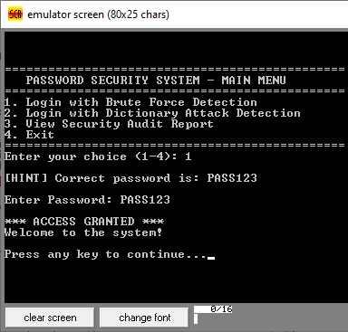

- Brute Force Attack Alerts. 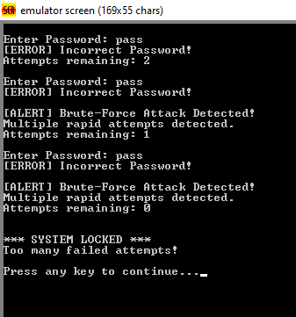

- Dictionary Attack Alerts. 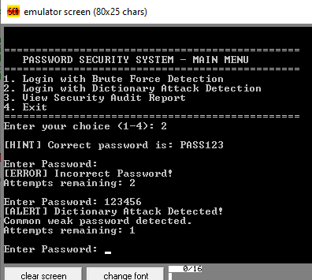

- Remaining attempts count.
- System Lock notification. 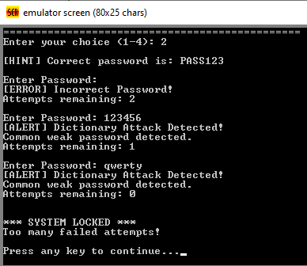

  - Security Audit Report including: Total login attempts.
  - Failed attempts.
  - Detected threats.
  - Current system status.
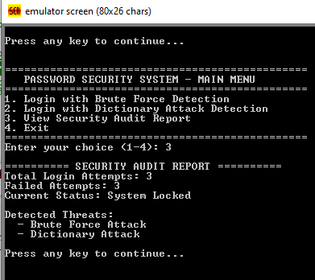

10. Security Features:
- Password masking logic.
- Attempt limitation.
- Attack detection flags.
- Automatic system lock.
- Audit logging.

11. Advantages:
- Efficient and fast execution.
- Low-level security implementation.
- Lightweight system design.
- Educational value.

12. Limitations:
- Fixed password length.
- No encryption or hashing.
- Limited dictionary size.
- Single-user support.

13. Future Enhancements:
- Password hashing implementation.
- Dynamic password update.
- Time-based brute force detection.
- Larger dictionary using advanced data structures.
- Multi-user authentication system.

15. Conclusion:
The Password Security System using Assembly Language successfully demonstrates at the lowest programming level. The project effectively detects brute force and dictionary attacks, limits unauthorized access, and provides a complete security audit report.
This project strengthens the understanding of security fundamentals and low-level programming, making it academically strong and practically relevant. THE END

